CANDIDATE APPLICATION FORM
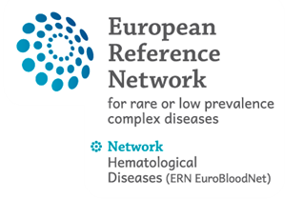

Educational program on Rare Hereditary Haemolytic Anaemia in Laboratories
HCP CUB-Hôpital Erasme / LHUB-ULB, Brussels, Belgium
19th – 22nd December 2022

Please complete all parts of the Application form
THE CANDIDATE
Name: Surname:
Specialisation:
Category (junior/senior):
Function:
Hospital where the participant is employed
- Name:
- Address:
- Email:
- Country:
- ERN Member or Affiliated Member:

If you have a disability, do you require any assistance during the preceptorship? Yes □ No □
Details of the assistance needed: ___________________________________________________
______________________________________________________________________________
_______________________________________________________________________________

The application form, A Curriculum vitae et studiorum and a cover letter should be send to: Dr Christel Buelens christel.buelens@ulb.be

* DECLARATION The information in this form is true and complete. I agree that any deliberate omission, falsification or misrepresentation in the application form will be grounds for rejecting this application. Where applicable, I consent that the organisation can seek clarification regarding registration details. I agree to the above declaration
*GDPR Agreement

I consent to having this website store my submitted information so they can respond to my inquiry.
Place, Date and signature
_____________________________________

This category is defined by the hospital as employer

